Module Name: Login Page
Test Case ID: 02
Webpage URL: Automation Exercise - Signup / Login

Scenario ID: 1
Scenario: Sign up with valid credentials
Test Steps:
1.Open website and register in the website.
2.Fill the name and email.
3.Click sign-up button.
4.Enter Account Information.
5.Enter address information.
6.Click create account button.
1.Open website and register in the website screenshot :
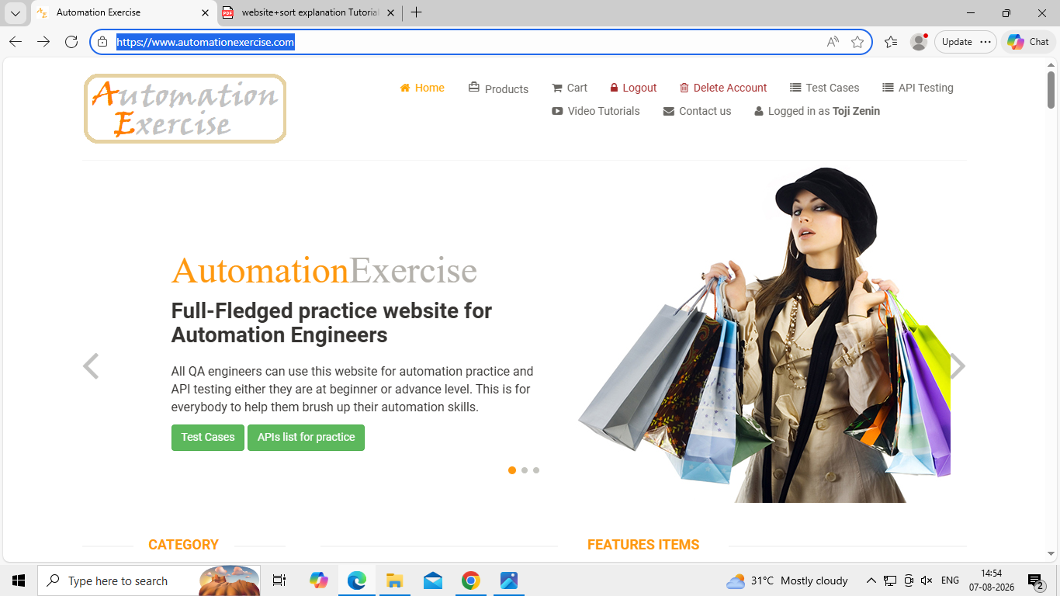

2. ScreenShot Of Fill the name and email :
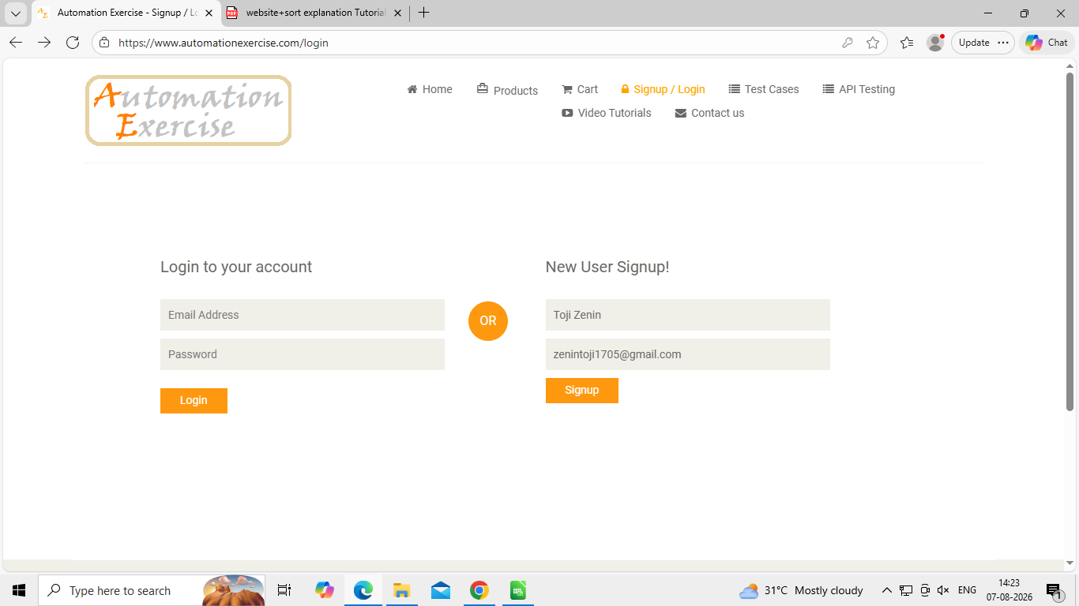
3. Screenshot of Click sign-up button :
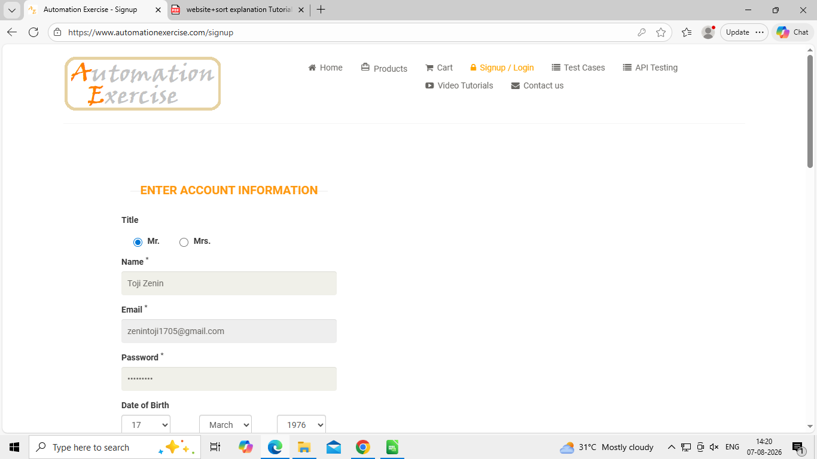

4.Screenshot of Enter Account Information :
5. Screenshot Enter address information :
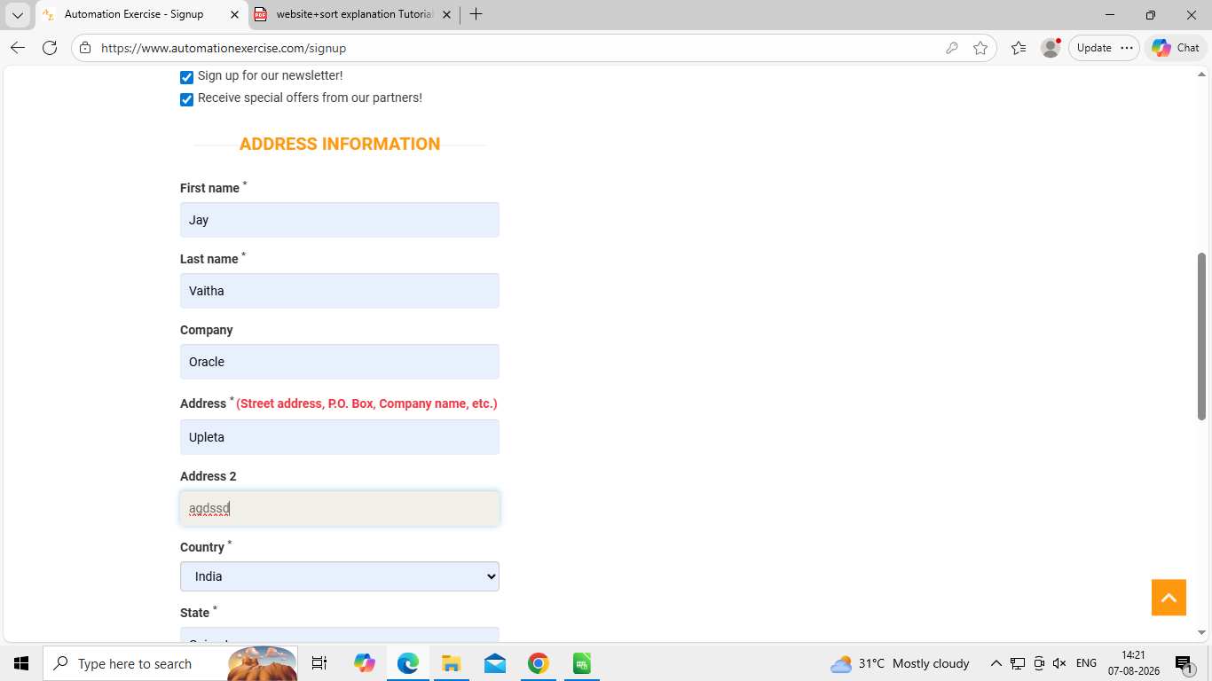

6. Screenshot Click create account button :
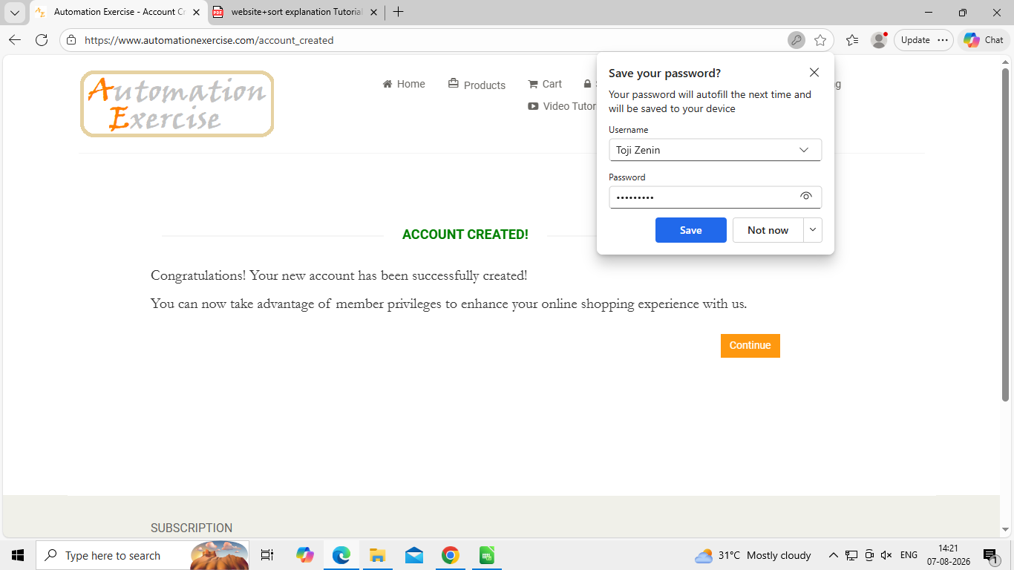

Scenario ID: 2

Scenario: Sign up with valid credentials
Test Steps:
1.Open website and register in the website.
2.Fill the name and email.
3.Click sign-up button.
4.Enter Account Information.
5.Enter address information.
6.Click create account button.

1.Open website and register in the website screenshot :
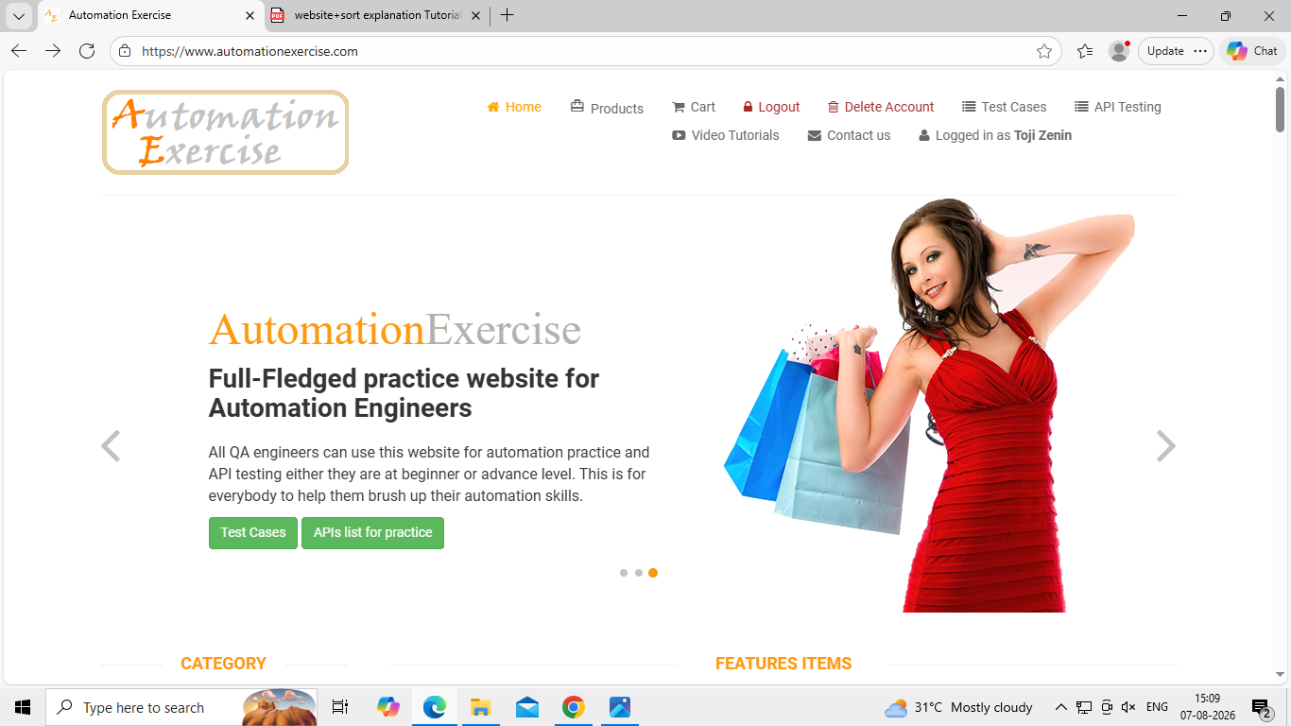
2. ScreenShot Of Fill the name and email :
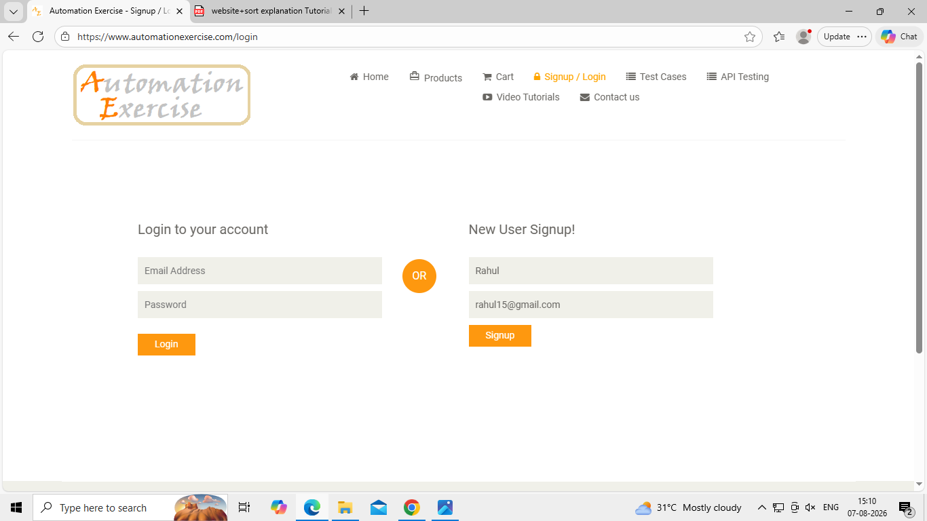

3. Screenshot of Click sign-up button :
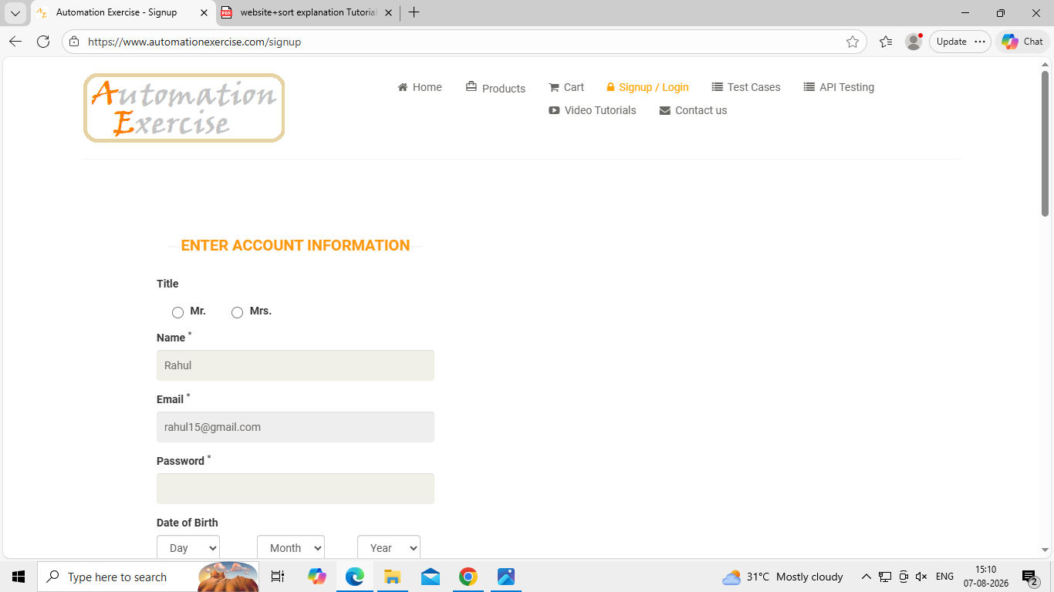
4.Screenshot of Enter Account Information :
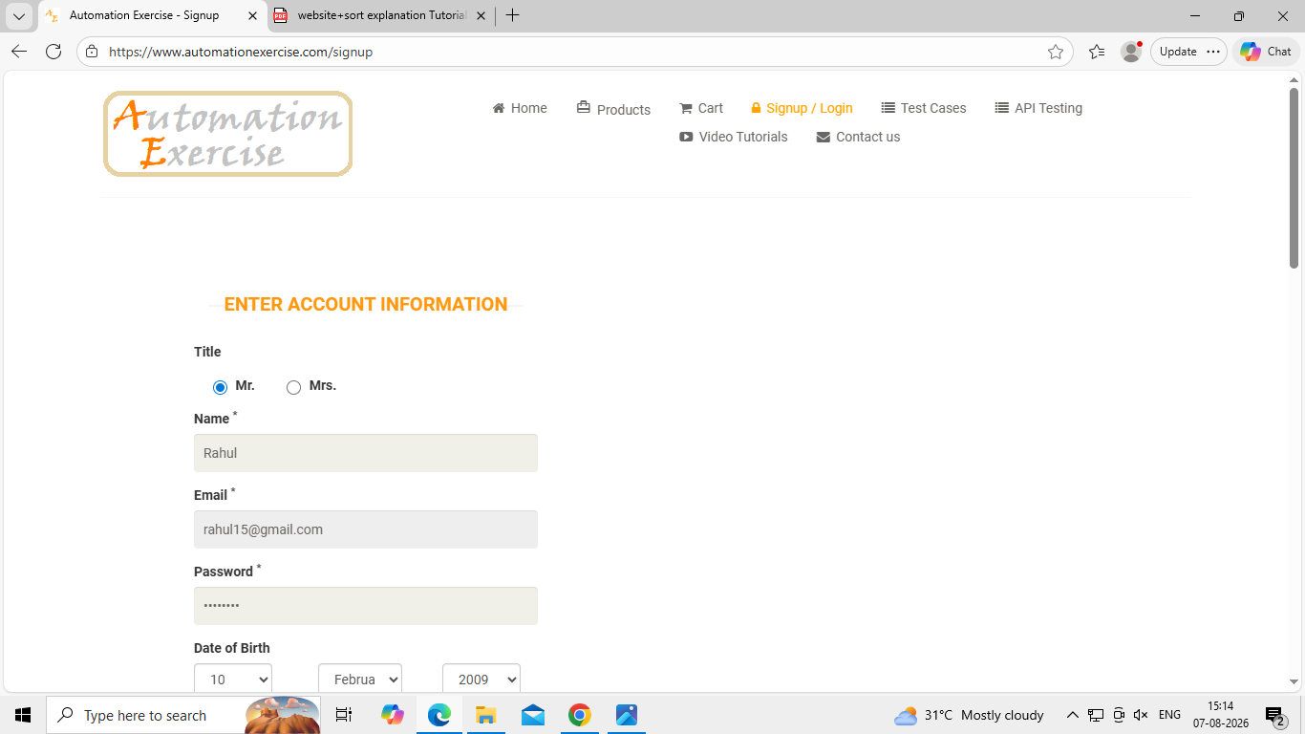

5. Screenshot Enter address information :
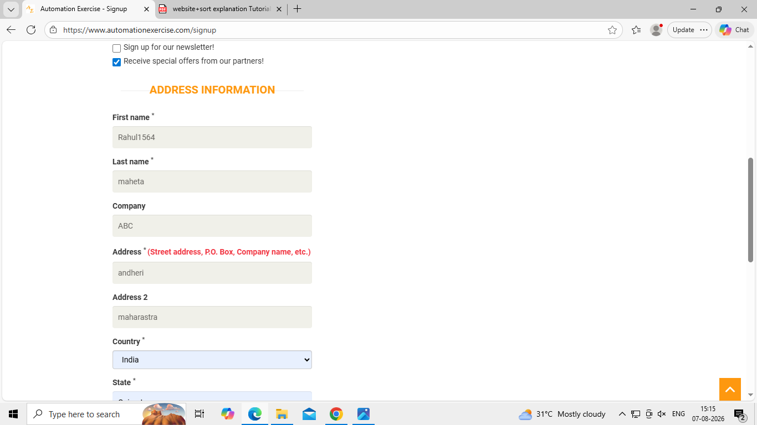

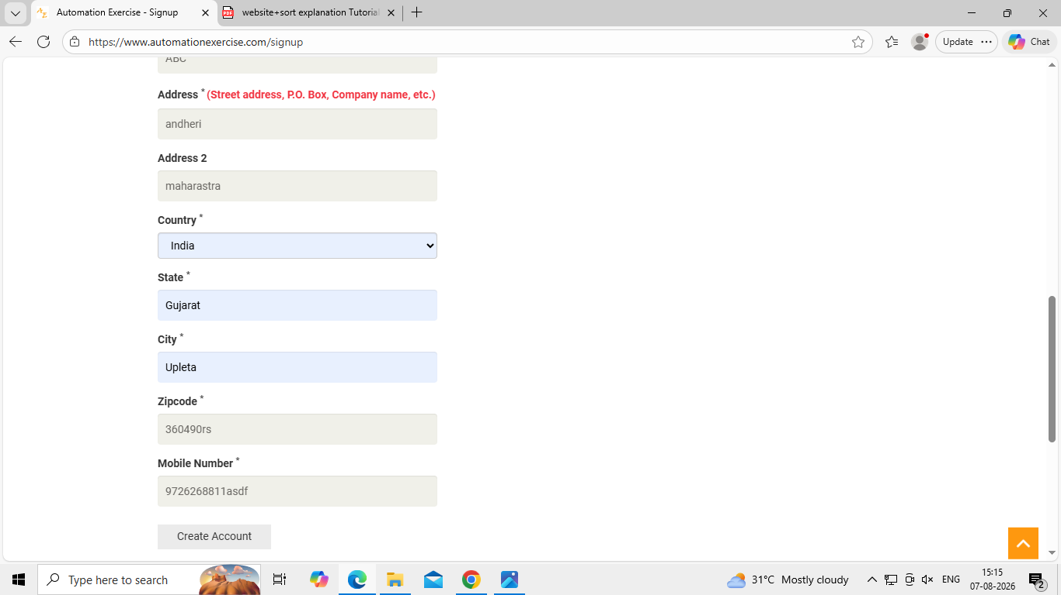

6. Screenshot Click create account button :
